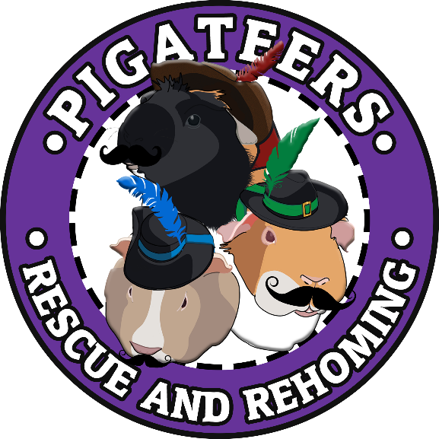
Pigateers Rescue & Rehoming
28 Elderflower Way
Downham Market
Norfolk
PE38 9US
Telephone: 07821733844
Email: pigateersrescueandrehoming@gmail.com

Pre-Adoption Form

Please make sure that you fill in all the * information
Name *
Date *
Address *

Postcode *
Home No *
Mobile No
Email *

Please add the information of the animal you would like to adopt.

Name if known *
Gender you would prefer *
Age you would prefer *
Please add photos of you housing situation where the animal will be living full term. Please attach them this to the email once you have filled in this form.
Please add information required below
How many animals do you own? *
What animals are they? *
How long have you had Guinea Pigs? *

*If this is your first time please make sure you state that you have not owned guinea pigs before. Please let us know what details you know about guinea pigs or websites that you have researched from.
Who are the sole carers who will look after the Guinea Pig/s? *
Who live within the household? *

Please make sure you sign, name and date this form.

Please date here
Name, Signature

Please read the information below. This is a MUST before adopting a Guinea Pig.
If you have any notes you wish to add, please add them below.

*To reserve a rescue guinea pig. A non-refundable deposit will be required, unless the guinea pig/s becomes ill or passes away, then we will refund the full deposit you put down. When the term ‘ill’ this means vet, treatment is needed. Rules out mites or ringworm, as this can be treated with a course of medication supplied by ourselves at Pigateers Rescue & Rehoming.
*Any child under the age of 18 years old cannot sign for the adoption form by themselves. A parent will need to sign alongside of the child adopting.
*The adoption fee ranges from £20 to £50. Donations are accepted.
- Guinea Pig- £20
- Skinny/Werewolf Pig- £50
- Castrated Male- £35
We do also offer the option of castration of one of our single loan boars within the rescue. We ask for the adopter to pay for the operation which costs £60, and then we do not ask for the Adoption fee for that named boar.
*If any problems arise, where the cavy can no longer be looked after the declared owner. The owner must contact Pigateers Rescue & Rehoming to find a new home. If the rescue has spaces available for the cavy named above, then it is in best wishes to return to the allocated rescue where the cavy came from.
*Any health issues that occur after the adoption, where our vet has given the all clear for the cavy named above. Does not fall back onto the rescue. If the cavy becomes ill, then it is recommended to get him/her to the vet as soon as possible. But if wanted, the declared owner can message the rescue for any advice. And we will try our best to help. We will not pay any outstanding fees if the guinea pig becomes ill after the adoption has taken place.
* We will add a vet consultation free of charge under the rescues name, once the adoption has taken place. This will occur are The Hollies Vet, Downham Market. If you do not wish this to happen then please let us know. Our vets are The Hollies Surgery, Downham Market & Vets 1 Group Limited, Crimplesham. For more serious illnesses we recommend the Vets 1 Group as they have a small animal specialist vet.

NOTES:

